**Project “Horrible Husky” - GDD**

*A Bop-it style video game*

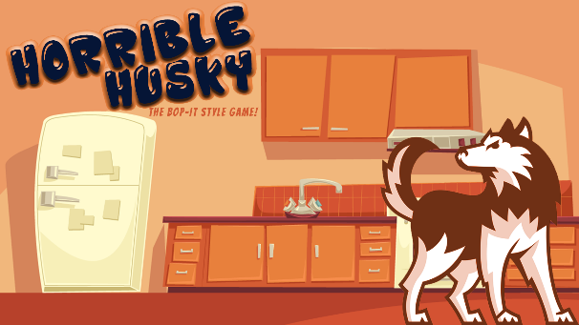 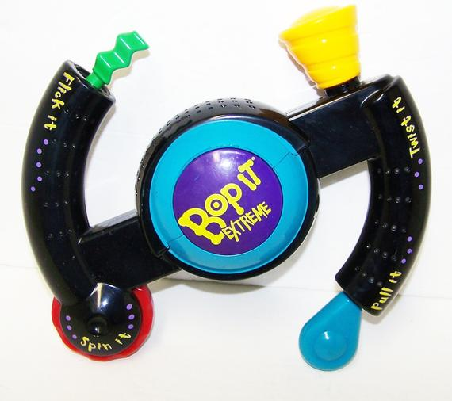

**Genre:** ​ Real time event game.

**Target Audience:** G (Suitable for all). ​

**Controls:** ​ Mouse (or) keyboard

**Thematic Setting:** ​ Cartoon, fake console style, living room / kitchen / bedroom etc.

**Tech Stack:** ​ Unity 6+, Photoshop, Audacity, Pixel tiling app

**Platform(s):** ​ Steam (mobile on 2nd phase)

**Game Moment:** ​ Stop the damage metre filling up by hitting buttons to control husky

**Game Summary:** Use M.U.S.H (Mind Ur Siberian Husky) V1.0 to keep your husky happy remotely and stop him / her from destroying your house whilst you are not home. The less bored your husky is, the less likely he’ll trash your home whilst you’re away. The longer you leave him the more agitated he’ll become and the quicker he’ll damage your home!

**Core Player Experience:**  Quick paced, real-time, urgency

**Central Theme:** Stop the husky from destroying your home

**Design Pillar:** Real-time and speed against the clock

**Anticipated Remarkability:** Random actions must be completed immediately and precisely or the player will be subject to a penalty.

**Anticipated Steam Early Access Launch date:** Q4, 2019.

**Anticipated Mobile Early Access Launch date:** Q1, 2020.

**Feature Development Priorities:**

* Title Screens and Instructions
* Main game moment scene
* Polishing and bug-fixing

**Comparative Products:** Bop-it and Bop-it extreme handheld toys